UNIT-II
Introduction:
Production is an important economic activity which satisfies the wants and needs of the people. Production function brings out the relationship between inputs used and the resulting output. A firm is an entity that combines and processes resources in order to produce output
that will satisfy the consumer’s needs. The firm has to decide as to how much to produce and how much input factors (labour and capital) to employ to produce efficiently. This chapter helps to understand the set of conditions for efficient production of an organization.

Factors of production include resource inputs used to produce goods and services. Economist categorise input factors into four major categories such as land, labour, capital and organization.

Land: Land is heterogeneous in nature. The supply of land is fixed and it is a permanent factor of production but it is productive only with the application of capital and labour.

Labour: The supply of labour is inelastic in nature but it differs in productivity and efficiency and it can be improved.

Capital: is a man made factor and is mobile but the supply is elastic.
Organization: the organization plans, , supervises, organizes and controls
the business activity and also takes risks.
Production Function
Production function indicates the maximum amount of commodity ‘X’ to be produced from various combinations of input factors. It decides on the maximum output to be produced from a given level of input, and how much minimum input can be used to get the desired level of output. The production function assumes that the state of technology is fixed. If there is a change in technology then there would be change in production function.
Q = f (Land, Labour, Capital, Organization)
Q = f (L, L, C, O)
The production manager’s responsibility is that of identifying the right combination of inputs for the decided quantity of output. As a manager ,he has to know the price of the input factors and the budget allocation of the organization. The major objective of any business organization is maximizing the output with minimum cost. To achieve the maximum output the firm has to utilize the input factors efficiently. In the long run, without increasing the fixed factors it is not possible to achieve the goal. Therefore it is necessary to understand the relationship between the input and output in any production process in the short and long run.

Law of variable Proportions
In economics, the production function with one variable input is illustrated with the well known law of variable proportions. (below graph) it shows the input-output relationship or production function with one factor variable while other factors of production are kept constant.
Statement of the law: This law states that “as the proportion of one factor in combination of other factors increases, first marginal production and then average production of that factor decreases.

Production Schedule
Labour | Total production | Average production | Marginal Production
1 | 20 | 20 | 0
2 | 54 | 27 | 34
3 | 81 | 27 | 27
4 | 104 | 26 | 23
5 | 125 | 25 | 21
6 | 138 | 23 | 13
7 | 147 | 21 | 9
8 | 152 | 19 | 5
9 | 152 | 17 | 0
10 | 150 | 15 | -3

The firm has a set of fixed variables. As long with that it increases the labour force from 1 unit to 10 units. The increase in input factor leads to increase in the output up to an extent. After that it start declining. Marginal production increases in the initial period and then it starts declining and it become negative. The firm should stop increasing labour force if the marginal production is zero- that is the maximum output that can be derived with the available fixed factors. The 9th labour does not contribute to any output. In case the firm wants to increase the output beyond 153 units it has to improve its fixed variable. That means purchase of new machinery or building is essential. Therefore the firm understands that the maximum output is 153 units with the given set of input factors.
Stage I: The total production increased at an increasing rate. We refer to this as increasing stage where the total product, marginal product and average production are increasing.
Stage II: The total production continues to increase but at a diminishing rate until it reaches the next stage. Marginal product, average product are declining but are positive. The total production is at the maximum level at the end of the second stage with a zero marginal product.
Stage III: In this third stage total production declines and marginal product becomes negative. And the average production also started decline. Which implies that the change in input factors there is a decline in the over all production along with the average and marginal.

The graphical representations of the production function are as shown in the following graph.

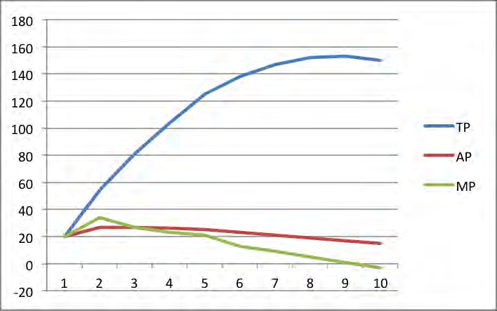
The graphical presentations of the values are shown in the graph. The ‘X” axis denotes the labour and the ‘Y’ axis indicates the total production (TP), average production (AP) and marginal production (MP). From the given table and graph we can understand all the three curves in the graph increased in the beginning and the marginal product (MP) first fell, then the average product (AP) finally total production (TP).The marginal production curve MP cuts the AP at its highest point. Total production TP falls when marginal production curve cuts the ‘X’ axis. The law of diminishing returns states that if increasing quantity of a variable input are combined with fixed, eventually the marginal product and then average product will decline.

Assumptions of the Law: This law is based on certain assumptions
i)It is possible to increase the production by increasing one input keeping other inputs constant.
ii) All the units of variable input should of same king and efficiency.
iii) It assumes a short period situation
iv) During that period technology remains unchanged.
v) Producer is using best method of production.

The Law Of Returns To Scale

In the long run the fixed inputs like machinery, building and other factors will change along with the variable factors like labour, raw material etc. With the equal percentage of increase in input factors various combinations of returns occur in an organization.

Returns to scale: the change in percentage output resulting from a percentage change in all the factors of production. They are increasing, constant and diminishing returns to scale.

Increasing returns to scale may arise: if the output of a firm increases more than in proportionate to an increase in all inputs. For example the input factors are increased by 50% but the output has doubled (100%).

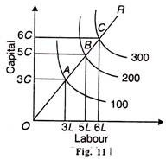

Constant returns to scale: when all inputs are increased by a certain percentage the output increases by the same percentage. For example input factors are increased by 50% then the output has also increased by 50 percentages. Let us assume that a laptop consists of 50 components we call it as a set. In case the firm purchases 100 sets they can assemble 100 laptops but it is not possible to produce more than 100 units.

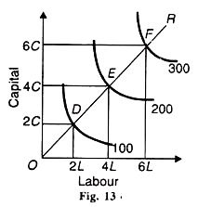

Decreasing returns to scale: when output increases in a smaller proportion than the increase in inputs it is known as diminishing return to scale. For example 50% increment in input factors lead to only 20% increment in the output.
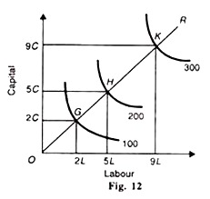
Causes of Increasing Returns to Scale:
a. Internal economies of scale
b. Efficiency of labour and capital
c. Improvement in large scale operation
d. Division of labour and specialization
e. Use of better and sophisticated technology
f. Economy of organisation
g. External economies of scale
Causes of Constant Returns to Scale:
a) Internal economics of scale are equal to internal diseconomies of scale.
b) Balancing of external economics and diseconomies of scale
c) Factors of production are perfectly divisible substitutable, homogenous and their supply is perfectly elastic at given prices.

Causes of Decreasing Returns to Scale
a. Internal diseconomies of scale
b. External diseconomies of scale
c. Increase in business risk
d. Lack of entrepreneurial efficiency
e. Unhealthy management and organization
f. Imperfect factor substitutability
g. Transport bottlenecks and Marketing difficulties.

COST CONCEPTS:

Cost Determinants

The cost of production of goods and services depends on various input factors used by the organization and it differs from firm to firm. The major cost determinants are:
1.Level of output: The cost of production varies according to the quantum of output. If the size of production is large then the cost of production will also be more.
2.Price of input factors: A rise in the cost of input factors will increase the total cost of production.
3.Productivities of factors of production: When the productivity of the input factors is high then the cost of production will fall.
4.Size of plant: The cost of production will be low in large plants due to mass production with mechanization.
5.Output stability: The overall cost of production is low when the output is stable over a period of time.
6.Lot size: Larger the size of production per batch then the cost of production will come down because the organizations enjoy economies of scale.
7.Laws of returns: The cost of production will increase if the law of diminishing returns applies in the firm.
8.Levels of capacity utilization: Higher the capacity utilization, lower the cost of production.
9.Time period: In the long run cost of production will be stable.
10.Technology: When the organization follows advanced technology in their process then the cost of production will be low.
COST CONCEPTS:
1. Money Cost and Real Cost
When cost is expressed in terms of money, it is called as money cost. It relates to money outlays by a firm on various factor inputs to produce a commodity. In a monetary economy, all kinds of cost estimations and calculations are made in terms of money only.
Hence, the knowledge of money cost is of great importance in economics. Exact measurement of money cost is possible.
When cost is expressed in terms of physical or mental efforts put in by a person in the making of a product, it is called as real cost. It refers to the physical, mental or psychological efforts, the exertions, sacrifices, the pains, the discomforts, displeasures and inconveniences which various members of the society have to undergo to produce a commodity. It is a subjective and relative concept and hence exact measurement is not possible.
2. Implicit or Imputed Costs and Explicit Costs
Explicit costs are those costs which are in the nature of contractual payments and are paid by an entrepreneur to the factors of production [excluding himself] in the form of rent, wages, interest and profits, utility expenses, and payments for raw materials etc. They can be estimated and calculated exactly and recorded in the books of accounts. Implicit or imputed costs are implied costs. They do not take the form of cash outlays and as such do not appear in the books of accounts. They are the earnings of owner employed resources.
3. Actual costs and Opportunity Costs
Actual costs are also called as outlay costs, absolute costs and acquisition costs. They are those costs that involve financial expenditures at some time and hence are recorded in the books of accounts. They are the actual expenses incurred for producing or acquiring a commodity or service by a firm. For example, wages paid to workers, expenses on raw materials, power, fuel and other types of inputs. They can be exactly calculated and accounted without any difficulty.
Opportunity cost of a good or service is measured in terms of revenue which could have been earned by employing that good or service in some other alternative uses.
4. Direct costs and indirect costs
Direct costs are those costs which can be specifically attributed to a particular product, a department, or a process of production. For example, expenses on raw materials, fuel, wages to workers, salary to a divisional manager etc are direct costs. On the other hand, indirect costs are those costs, which are not traceable to any one unit of operation. They cannot be attributed to a product, a department or a process.
For example, expenses incurred on electricity bill, water bill, telephone bill, administrative expenses etc.
5. Past and future costs.
Past costs are those costs which are spent in the previous periods. On the other hand, future costs are those which are to be spent. in the future. Past helps in taking decisions for future.
6. Marginal and Incremental costs
Marginal cost refers to the cost incurred on the production of another or one more unit.
It implies additional cost incurred to produce an additional unit of output It has nothing to do
with fixed cost and is always associated with variable cost. Incremental cost on the other hand refers to the costs involved in the production of a batch or group of output. They are the added costs due to a change in the level or nature of business activity.
For example, cost involved in the setting up of a new sales depot in another city or cost involved in the production of another 100 extra units.
7. Fixed costs and variable costs.
Fixed costs are those costs which do not vary with either expansion or contraction in output. They remain constant irrespective of the level of output. They are positive even if there is no p On the other hand, variable costs are those costs which directly and proportionately increase or decrease with the level of output produced. They are also called as prime costs or direct costs.
8. Accounting costs and economic costs.
Accounting costs are those costs which are already incurred on the production of a particular commodity. It includes only the acquisition costs. They are the actual costs involved in the making of a commodity. On the other hand, economic costs are those costs that are to be incurred by an entrepreneur on various alternative programs. It involves the application of opportunity costs in decision making. roduction .They are also called as supplementary or over head costs.

Cost-Output Relationship
A proper understanding of the nature and behavior of costs is a must for regulation and control of cost of production. The cost of production depends on money forces and an understanding of the functional relationship of cost to various forces will help us to take various decisions. Output is an important factor, which influences the cost.
The cost-output relationship plays an important role in determining the optimum level of production. Knowledge of the cost-output relation helps the manager in cost control, profit prediction, pricing, promotion etc. The relation between cost and its determinants is technically described as the cost function.
C= f (S, O, P, T ….)
Where;
- C= Cost (Unit or total cost)
- S= Size of plant/scale of production
- O= Output level
- P= Prices of inputs
- T= Technology

Cost-Output Relationship in the Short-Run
The cost concepts made use of in the cost behavior are Total cost, Average cost, and Marginal cost.
Total cost is the actual money spent to produce a particular quantity of output. Total Cost is the summation of Fixed Costs and Variable Costs.
TC=TFC+TVC
Up to a certain level of production Total Fixed Cost i.e., the cost of plant, building, equipment etc, remains fixed. But the Total Variable Cost i.e., the cost of labor, raw materials etc., vary with the variation in output. Average cost is the total cost per unit. It can be found out as follows.
AC=TC/Q
The total of Average Fixed Cost (TFC/Q) keep coming down as the production is increased and Average Variable Cost (TVC/Q) will remain constant at any level of output.
Marginal Cost is the addition to the total cost due to the production of an additional unit of product. It can be arrived at by dividing the change in total cost by the change in total output.
In the short-run there will not be any change in Total Fixed C0st. Hence change in total cost implies change in Total Variable Cost only.

Units of output(Q) | Total fixed cost(TFC) | Total variable cost(TVC) | Total cost(TC)  (TFC+TVC) | Average variable cost(AVC)  (TVC/Q | Average fixed cost(AFC)  (TFC/Q)
0 | 60 | - | 60 | - | -
1 | 60 | 20 | 80 | 20 | 60
2 | 60 | 36 | 96 | 18 | 30
3 | 60 | 48 | 108 | 16 | 20
4 | 60 | 64 | 124 | 16 | 15
5 | 60 | 90 | 150 | 18 | 12
6 | 60 | 132 | 192 | 22 | 10

The above table represents the cost-output relationship. The table is prepared on the basis of the law of diminishing marginal returns. The fixed cost Rs. 60 May include rent of factory building, interest on capital, salaries of permanently employed staff, insurance etc. The table shows that fixed cost is same at all levels of output but the average fixed cost, i.e., the fixed cost per unit, falls continuously as the output increases. The expenditure on the variable factors (TVC) is at different rate. If more and more units are produced with a given physical capacity the AVC will fall initially, as per the table declining up to 3rd unit, and being constant up to 4th unit and then rising. It implies that variable factors produce more efficiently near a firm’s optimum capacity than at any other levels of output and later rises. But the rise in AC is felt only after the start rising. In the table ‘AVC’ starts rising from the 5th unit onwards whereas the ‘AC’ starts rising from the 6th unit only so long as ‘AVC’ declines ‘AC’ also will decline. ‘AFC’ continues to fall with an increase in Output. When the rise in ‘AVC’ is more than the decline in ‘AFC’, the total cost again begin to rise. Thus there will be a stage where the ‘AVC’, the total cost again begin to rise thus there will be a stage where the ‘AVC’ may have started rising, yet the ‘AC’ is still declining because the rise in ‘AVC’ is less than the droop in ‘AFC’.
Thus the table shows an increasing returns or diminishing cost in the first stage and diminishing returns or diminishing cost in the second stage and followed by diminishing returns or increasing cost in the third stage.
The short-run cost-output relationship can be shown graphically as follows.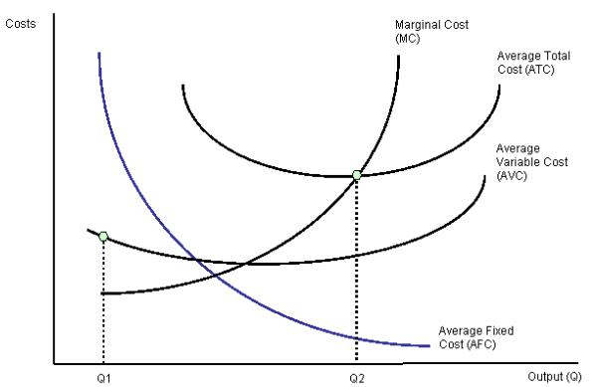
In the above graph the “AFC’ curve continues to fall as output rises an account of its spread over more and more units Output. But AVC curve (i.e. variable cost per unit) first falls and than rises due to the operation of the law of variable proportions. The behavior of “ATC’ curve depends upon the behavior of ‘AVC’ curve and ‘AFC’ curve. In the initial stage of production both ‘AVC’ and ‘AFC’ decline and hence ‘ATC’ also decline. But after a certain point ‘AVC’ starts rising. If the rise in variable cost is less than the decline in fixed cost, ATC will still continue to decline otherwise AC begins to rise. Thus the lower end of ‘ATC’ curve thus turns up and gives it a U-shape. That is why ‘ATC’ curve are U-shaped. The lowest point in ‘ATC’ curve indicates the least-cost combination of inputs. Where the total average cost is the minimum and where the “MC’ curve intersects ‘AC’ curve, It is not be the maximum output level rather it is the point where per unit cost of production will be at its lowest.
The relationship between ‘AVC’, ‘AFC’ and ‘ATC’ can be summarized up as follows:
- If both AFC and ‘AVC’ fall, ‘ATC’ will also fall.
- When ‘AFC’ falls and ‘AVC’ rises
  - ‘ATC’ will fall where the drop in ‘AFC’ is more than the raise in ‘AVC’.
  - ‘ATC’ remains constant is the drop in ‘AFC’ = rise in ‘AVC’
  - ‘ATC’ will rise where the drop in ‘AFC’ is less than the rise in ‘AVC’

Cost-output Relationship in the Long-Run
Long run is a period, during which all inputs are variable including the one, which are fixes in the short-run. In the long run a firm can change its output according to its demand. Over a long period, the size of the plant can be changed, unwanted buildings can be sold staff can be increased or reduced. The long run enables the firms to expand and scale of their operation by bringing or purchasing larger quantities of all the inputs. Thus in the long run all factors become variable.
The long-run cost-output relations therefore imply the relationship between the total cost and the total output. In the long-run cost-output relationship is influenced by the law of returns to scale.In the long run a firm has a number of alternatives in regards to the scale of operations. For each scale of production or plant size, the firm has an appropriate short-run average cost curves. The short-run average cost (SAC) curve applies to only one plant whereas the long-run average cost (LAC) curve takes in to consideration many plants.
The long-run cost-output relationship is shown graphically with the help of “LCA’ curve.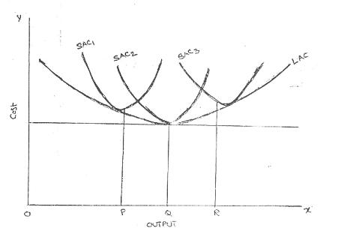
To draw on ‘LAC’ curve we have to start with a number of ‘SAC’ curves. In the above figure it is assumed that technologically there are only three sizes of plants – small, medium and large, ‘SAC’, for the small size, ‘SAC2’ for the medium size plant and ‘SAC3’ for the large size plant. If the firm wants to produce ‘OP’ units of output, it will choose the smallest plant. For an output beyond ‘OQ’ the firm wills optimum for medium size plant. It does not mean that the OQ production is not possible with small plant. Rather it implies that cost of production will be more with small plant compared to the medium plant.
For an output ‘OR’ the firm will choose the largest plant as the cost of production will be more with medium plant. Thus the firm has a series of ‘SAC’ curves. The ‘LCA’ curve drawn will be tangential to the entire family of ‘SAC’ curves i.e. the ‘LAC’ curve touches each ‘SAC’ curve at one point, and thus it is known as envelope curve. It is also known as planning curve as it serves as guide to the entrepreneur in his planning to expand the production in future. With the help of ‘LAC’ the firm determines the size of plant which yields the lowest average cost of producing a given volume of output it anticipates.
BREAK EVEN ANALYSIS:
Profit is the main objective of every business organisation. During the process of earning profit every business will be facing many uncertainties such as marketing uncertainties, technical uncertainties, demand uncertainties ect., because of nature of competition, technological advancement, change in the taste and preference of customers. So unless the firm is prepared to face these uncertainties its profit would be left to chance. So, naturally every firm will be preparing proper plan for its profit.
In order to plan for the profit business managers should have through understanding of relationship between cost ,revenue ,volume of sales and profits of the organisation. The most important method of determining the relationship between cost, volume, profit of the firm is break – even analysis (or) CVP analysis.
Break-even analysis involves the study of cost of production on one hand, revenue and profit obtained from the sales on the other hand specifically to determine that volume of sales at which the firms cost and revenue will be equal.
Break-even point: It may be defined as that level of sales at which the firms total revenue is equal to total cost and the net income is equal to zero. This is also known as no profit and no loss point.
Determination of Breake-Even Point(BEP):Break-even point can be ascertained by using the following formula:
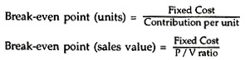
Contribution per unit= Selling price per unit-variable cost per unit
P/V Ratio= contribution/sales
Contribution=Sales-variable cost
(or)
Contribution=Fixed cost+profit
Margin of safety=profit/pv ratio

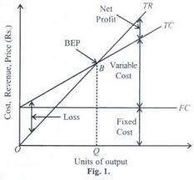
Assumptions of Break-Even Analysis:
The break-even analysis is based on certain assumptions.ThThey are:
(i) All costs can be separated into fixed and variable components.
(ii) Fixed costs will remain constant at all volumes of output.
(iii) Variable costs will fluctuate in direct proportion to volume of output.
(iv) Selling price will remain constant.
(v) Product-mix will remain unchanged.
(vi) The volume of sales is equal to volume of production.
(vii) cost and revenue depends only on volume not on any other factor.
Uses of Break-Even Analysis:
(i) It helps in the determination of selling price which will give the desired profits.
(ii) It helps in the fixation of sales volume to cover a given return on capital employed.
(iii) It helps in forecasting costs and profit as a result of change in volume.
(iv) It gives suggestions for shift in sales mix.
(v) It helps in making inter-firm comparison of profitability.
(vi) It helps in determination of costs and revenue at various levels of output.
(vii) It is an aid in management decision-making (e.g., make or buy, introducing a product etc.), forecasting, long-term planning and maintaining profitability.
(viii) It reveals business strength and profit earning capacity of a concern without much difficulty and effort.
Limitations of Break-Even Analysis:
1. Break-even analysis is based on the assumption that all costs and expenses can be clearly separated into fixed and variable components. In practice, however, it may not be possible to achieve a clear-cut division of costs into fixed and variable types.
2. It assumes that fixed costs remain constant at all levels of activity. It should be noted that fixed costs tend to vary beyond a certain level of activity.
3. It assumes that variable costs vary proportionately with the volume of output. In practice, they move, no doubt, in sympathy with volume of output, but not necessarily in direct proportions..
4. The assumption that selling price remains unchanged gives a straight revenue line which may not be true. Selling price of a product depends upon certain factors like market demand and supply, competition etc., so it, too, hardly remains constant.
5. The assumption that only one product is produced or that product mix will remain unchanged is difficult to find in practice.
6. Apportionment of fixed cost over a variety of products poses a problem.
7. It assumes that the business conditions may not change which is not true.
8. It assumes that production and sales quantities are equal and there will be no change in opening and closing stock of finished product, these do not hold good in practice.
9. The break-even analysis does not take into consideration the amount of capital employed in the business. In fact, capital employed is an important determinant of the profitability of a concern.

